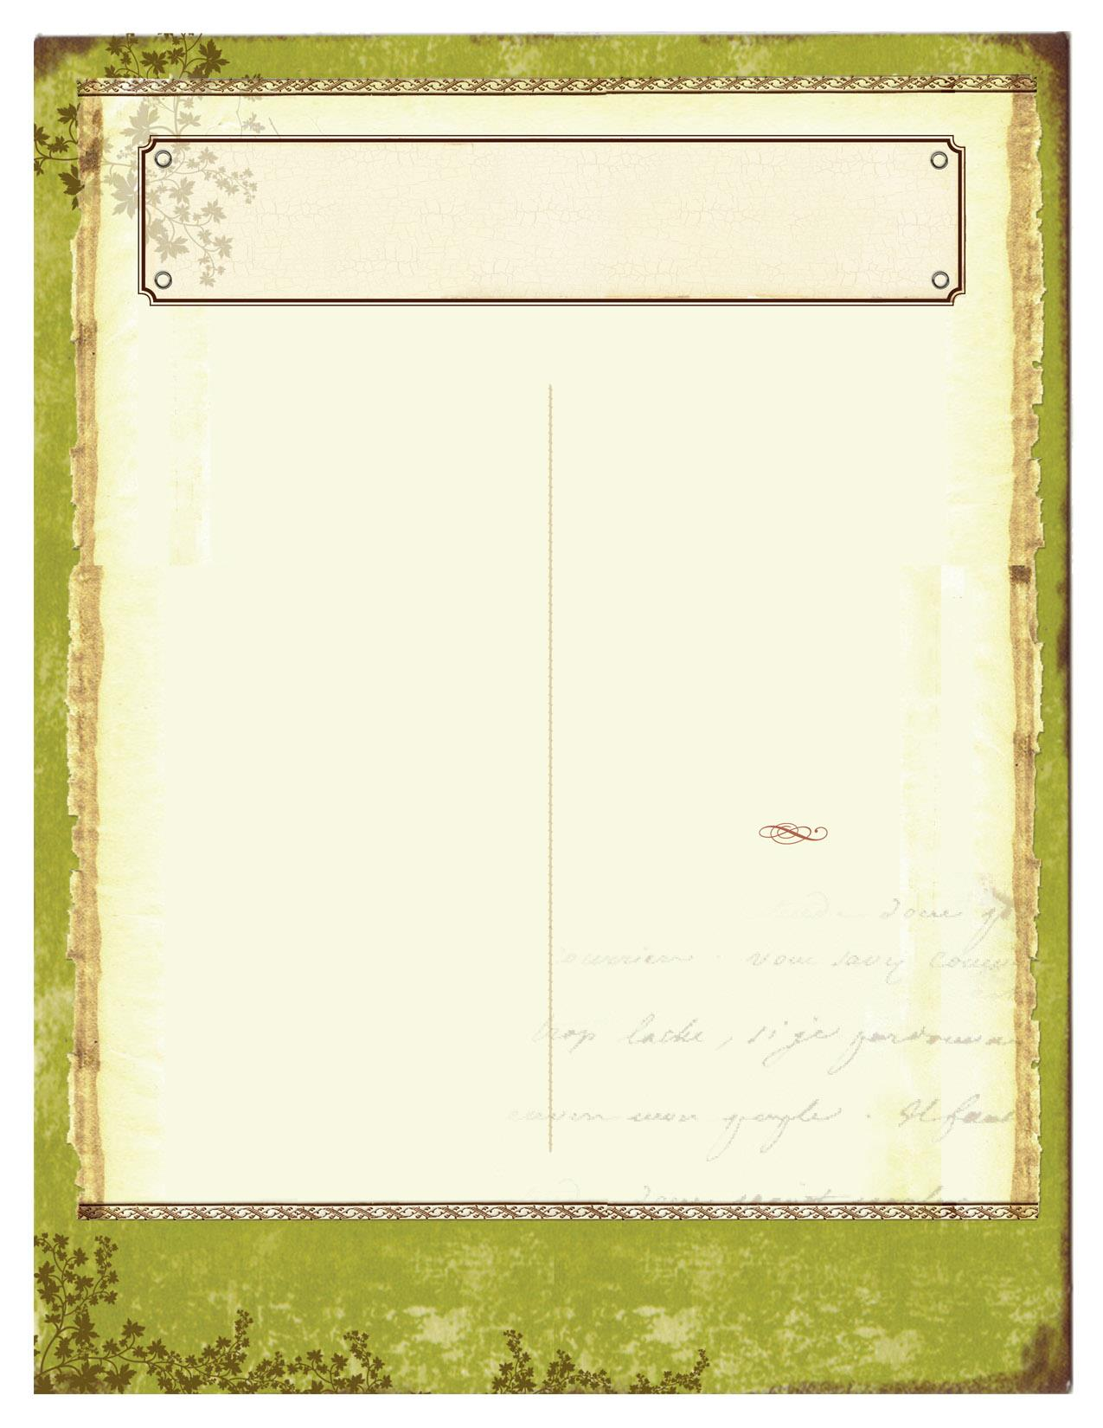

**Event: Murder is a Fine Art: A Murder Mystery Dinner**

**Date & Time:** Saturday, February 13 from 7-10pm

**Location:** Iron Gate Vineyards

**Details:** Libby Labelle, art critic for the influential “Graphic News,” used her vitriolic columns to destroy the careers of many artists. When it was announced that impressionist artist Pete Casso was to preview an upcoming exhibit at the Creative Connection Art Gallery, Libby made a point of letting everyone know she’d be there to, once again, pen a negative review which never got printed. The reason, Libby collapsed in the gallery and died. It would take a palette of investigative skills to solve the case and identify the murderer. Enjoy a delicious dinner with your favorite Iron Gate wine. Then put your detective skills to work as the AboutTownTours—ComeSolveIt—Charlotte Players challenge you with their latest murder mystery. The dinner menu will be posted as soon as it is confirmed with the caterer. Please notify Iron Gate Vineyards at least two weeks prior to the dinner if you have any special dietary restrictions. For more information please visit [www.irongatevineyards.com](http://www.irongatevineyards.com) or call (919) 304-9463

**Event: Haw River Historical Museum presents School Desegregation**

**Date & Time:** Tuesday, February 23 at 7pm

**Location:** Haw River Historical Museum

**Details:** This is a free event. Dr. Jim Bissette, a history professor at Elon University, will talk about the Burlington and Alamance County School systems in the 1960's.

**February 2016**

**Event: Cheers for Chocolate Festival**

**Date & Time:** Saturday, February 6from 11 am- 3pm

**Location:** Holly Hill Mall in Burlington

**Details:** Let's cheer for chocolate samples and any excuse to get together in the name of cocoa. A silent auction will also be taking place. All proceeds benefit Christmas Cheer, a nonprofit that serves underprivileged children and elderly of Alamance County. Tickets $5 for 5 samples and $10 for 10 samples. For more information, visit www.christmascheerofalamance.org

**Event: Dinner and Jazz**

**Date & Time:** Saturday, February 13 at 4pm

**Location:** Walter H. Williams High School

**Details:** Kick off your Valentine's weekend by joining the WHS Jazz Ensemble and Guest Artist including vocalist Diana Thompson-Brewer and pianist Greyson Clifton. Dinner includes spaghetti, bread, salad, drinks and desserts! In addition to live music, there will be a photo-booth and the option to purchase pictures. Cost is 15$ per person.

**Event: “Hairspray” produced by the Gallery Players**

**Date & Time:** February 19-21, 26 & 28

**Location:** Paramount Theatre in Burlington, NC

**Details:** Show times are as follows: Thursday-Saturday at 8pm and Sunday at 2pm. Tickets costs for adults are $16 and seniors and students are $13. For more information please visit our Facebook page.

AREA EVENTS

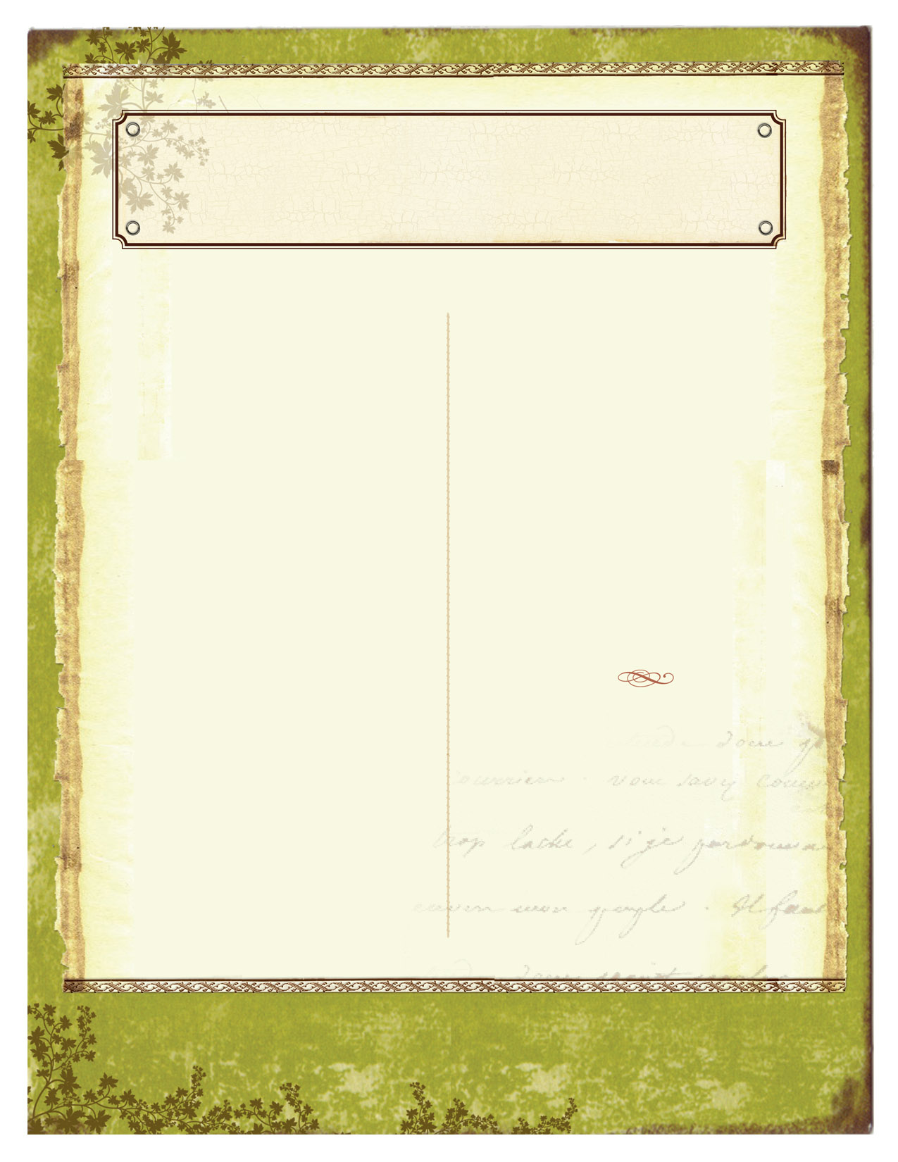

**February 2016**

**Event: Alamance Photography Club Exhibition**

**Date & Time:** February 1-29

**Location:** The Point of View Art Gallery

**Details:** An exhibit of original photography by members of the Alamance Photography Club, "What We See!" covers a wide range of subjects and features some of the newest and best works by members of this talented and enthusiastic group.

**Event: Live Music and Line Dancing**

**Date & Time:** Every Saturday night

**Location:** Haw River Historical Museum

**Details:** Tony and all the members of The Bandits are Home Grown in North Carolina! They will rock you every Saturday Night with best of Classic Country, Beach, Oldies Rock & Roll and Gospel - Come on out and join the fun! Adult - $11, Seniors - $10 Members - $8 18 & Under - $5 Doors open at 5pm, line dancing lessons from 6-7pm, show starts at 7:30pm

**Event: Greensboro Symphony Tanger Outlets Masterworks Series: Winter Dreams**

**Date & Time:** Thursday, February 25 & 27 from 8-10pm

**Location:**Guilford College

**Details:** February 25/27, 2016 located in the Dana Auditorium. There will be video collage paintings by Aleksander & Lyuba Titovets, Tchaikovsky Symphony No. 1, “Winter Dreams”, Tchaikovsky Suite from Sleeping Beauty, and Tchaikovsky 1812 Overture. Prices are $34-46 for adults and $6 for students.Performances by Greensboro Symphony Orchestra.

AREA EVENTS EVENTS

**Event: Central Carolina Boat and Fish Expo**

**Date & Time:** February 26-28

**Location:** Greensboro Coliseum

**Details:** Cost- Adults $8, Seniors 60+ & Military $7, Jr. Anglers (6-12) $5, and Children 5 and under are Free. Friday 10am – 8:30pm Saturday 9am – 7pm Sunday 10am – 5pm. Admission is good for all three days with return pass. Discounts available until day before the show, visit www.greensborofishingexpo.com

**Event: ​Department of Performing Arts presents 'The Light in the Piazza'**

**Date & Time:** February 11-14

**Location:** Elon University McCrary Theatre

**Details:** McCrary Theatre, Thursday - Saturday, 7:30 p.m.; Sunday, 2 p.m.

Set in the 1950s, this musical revolves around Margaret, a wealthy North Carolinian, and her daughter Clara who spend a summer together in Italy where Clara falls in love with a young Italian man. As the story unfolds, a secret is revealed. Clara is not quite all that she appears to be. Unable to suppress the truth about her daughter, Margaret is forced to reconsider her hopes for both of their futures.

Admission: $13 or Elon ID. Tickets available Thursday, January 21.

**Event: Art Class @ The Grove**

**Date & Time:** Wednesday, February 17 2016, 6:30pm – 7:30pm

**Location:** Grove Winery

**Details:** Fun, casual painting class lead by Bottles & Brushes at Grove Winery. For more information please visit www.grovewinery.com